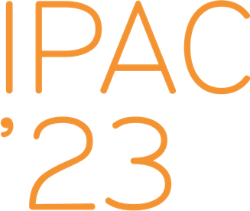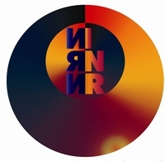

**Reference letter**

**for IPAC’23 student grant application for a PhD student Sergey Kolokol’chikov**

Sergey is a promising PhD student at the Institute for Nuclear Research of the Russian Academy of Sciences (INR RAS) whose research in spin dynamics in various upgraded modes of operation of the Nuclotron-based Ion Collider fAcility (NICA), property of the Joint Institute for Nuclear Researches (JINR), is ultimately dedicated to the search for the electric dipole moment (EDM).

NICA was not designed with the EDM in mind; primarily it is a collider for experiments with heavy ions and polarized proton and deuteron beams. Hence arose the difficult task of modifying the existent NICA structure for the EDM experiments. Sergey accepted this challenge and, in my opinion, is handling it well. In particular, he designed a channel optics to by-pass the collider interaction points in the existing straight sections and to compensate spin-rotations in the arcs, thus fulfilling the so-called «Quasi-Frozen Spin» condition required for the EDM experiment. He also studied spin-dynamics in the modified lattice and discovered a mismatch between the lattice’s optimal parameters with respect to the beam spin coherence and its betatron chromaticity. At the IPAC’23 he is going to present the results of these two studies.

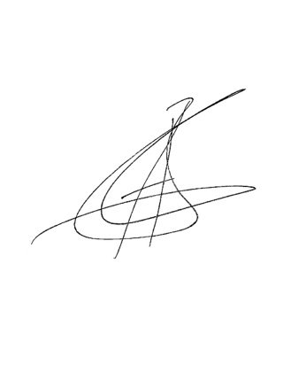 In the light of the importance the work he’s engaged in has in general, and his personal contributions to this effort, I think Sergey deserves a place among the contestants for the student grant.

**PhD, accelerator scientist at INR RAS, MEPHI**

**Alexander Aksentyev (alexaksentyev@gmail.com)**